INTRODUCTION OF A NEW CONCEPT IN ANTENNA THEORY,
ALIAS
THE POYNTING ANTENNA.
by
Ted Hart W5QJR CEO EH Antenna Systems, LLC

INTRODUCTION: A long time ago (1880) Mr. Hertz conceived the resonant antenna that is in common use today. Move forward to the current time – and be introduced to a new technology based on the Poynting Theorem. Now we have two (2) types of antennas. In particular, the EH Antenna is an implemented form of the Poynting antenna and was created and patented by the author. For radio communications this is a true paradigm shift. The major difference between the Hertz antenna and the Poynting antenna are presented below. The one thing in common is that radiation is developed by combining the electric and magnetic fields. They must be in time phase and physically orthogonal. The method of developing the fields is the difference.

HERTZ ANTENNA: When power is applied to the Hertz antenna current travels along the wire creating the magnetic field. As that field changes (it is a sine wave) it creates an electric field. You could ask which came first the chicken or the egg. If the applied voltage created an electric field then a changing electric field creates a magnetic field. In either case there is a time phase difference of 90 degrees between the electric (E) and Magnetic (H) field. Because the two fields travel thru space at different rates, they do not combine to create radiation until they are in phase at some distance from the antenna known as the far field.
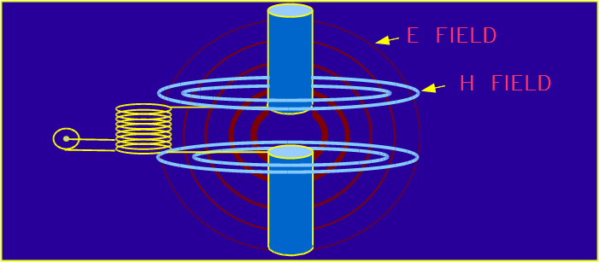
POYNTING ANTENNA: The Poynting antenna develops the E and H fields simultaneously; therefore they can be efficiently integrated at the antenna. In other words, the far field has been moved to the Poynting antenna. The significant advantages will be enumerated later. The figure illustrates the concept. Note that a tuning coil in parallel with the capacity of the antenna causes the system to be resonant at the operating frequency. This develops a very high voltage between the two elements of the antenna. An electric (E) field is intense between the antenna elements and diminishes to zero at the ends of the elements. The differential voltage across each element causes current to flow on the element thus creating a magnetic field surrounding the element. Unlike the Hertz antenna, the two fields are developed simultaneously and in proper physical relationship allowing them to be efficiently integrated to produce radiation. How can the differential voltage develop enough current thus large enough magnetic field? The current is low because the ratio of the electric and magnetic fields must have a ratio of 377 ohms, the impedance of free space.

BACKGROUND: It is interesting to note that Mr. Poynting created the Poynting theorem about the same time Hertz created the resonant antenna. However, until the author developed the EH Antenna (so named due to the simultaneous existence of the fields) numerous documents have been written but never converted to actual practice. In 1986 Mr. Hatley , a college Professor in Scotland, created the Crossed Field Antenna where the E and H fields were developed separately then combined, thus the name. In 1996 the Author played with the concept of developing the E and H fields simultaneously. Numerous experiments followed. Then, in 2006 the Department of Defense funded further development of the antenna. It was not until 2012 that Paul Birke (VE3PVB) joined me to co-author a book on the Poynting antenna that allowed very significant progress to be made. Paul’s background in field theory enabled the optimum physical design which is a Flute. Further, Paul has been able to delve deeply into the theory of the Poynting antenna. The book will be published in 2013.

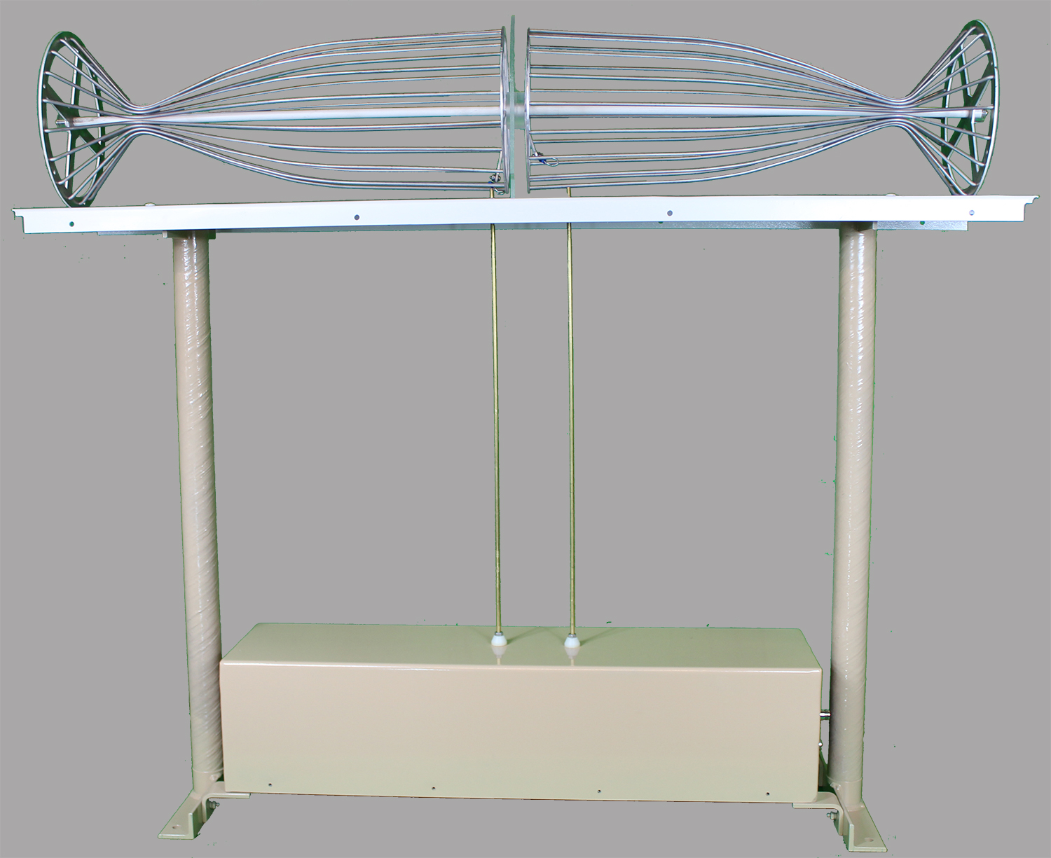
Recently a new company (Alpha Cognetics, LLC) was formed to manufacture and market the antenna. At this time only commercial and military versions are available. These cover the 3.5 to 8 MHz frequency range for Near Vertical Incidence Signal (NVIS) communications. The antenna is shown without the radome. The automatic tuning unit is in the lower enclosure. Application of a low power RF signal will cause automatic tuning. The antenna may be located remotely. DC power for the tuner is carried on the RF coax. The dimensions of the antenna are 4 feet in width and 4 feet in height. The primary application is for mounting on rooftops of large buildings and on vehicles, or it can be ground mounted.

COMPARISON: The following is a tabulation of the more important parameters of the antennas allowing direct comparisons:
PARAMETER: HERTZ ANTENNA EH ANTENNA
SIZE (DIPOLE) ½ WAVELENGTH 1 TO 5% OF A WAVLENGTH
DIPOLE HEIGHT ¼ WAVLENGTH A FEW FEET
SIZE (VERTICAL) ¼ WAVELENGTH 1TO5% OF A WAVELENGTH
RADIALS FOR VERTICAL 120 EACH ¼ WAVE NONE REQUIRED
BANDWIDTH NARROW VERY WIDE
EFFICIENCY GAIN STANDARD SEE ATTACHED PLOTS
PATTERN FIGURE 8 ISOTROPIC SOURCE
POLARIZATION LINEAR CIRCULAR
RECEPTION: ½ WAVE DIPOLE NOMINALLY SAME AS A DIPOLE
The following comments are for the purpose of explaining the above parameters that are not readily obvious:
SIZE: the EH Antenna can be very small because the E and H fields are very efficiently integrated to produce radiation. However, when the EH antenna is less than 1% the efficiency falls off. When it is greater than 5% it has strange behavior. For those reasons a length of 3% of a wavelength is the typical design. The ANTENNA shown above covers 3.2 to 11 MHz, a range (in wavelengths) of 1.3% to 4.5%. The useful range for typical NVIS communications is 3.5 to 8 MHz.
RADIALS: When oriented horizontally or vertically the EH Antenna is a full dipole, therefore radials are not required.
BANDWIDTH: High radiation resistance combined with high element to element capacity provides a low Q resonant circuit meaning wide bandwidth.
PATTERN: The very small size of the EH antenna results in an isotropic radiation pattern.
POLARIZATION: Because the pattern is non-directional, signals transmitted or received are equal from any direction. This virtually eliminates fading due to Faraday rotation of the signals and from multiple reflections. A dipole has 2.14 dBi gain but an isotropic source has a relative gain of 0 dBi. However, when a 9 inch tall EH Antenna was compared to a ¼ wave whip at 27 MHz the EH Antenna was 3 dB better. This was attributed to the Hertz vertical antenna having very large E and H fields and interacting with the vehicle and ground to create loss.
MOUNTING: Due to the E and H fields existing only within the spherical volume of the EH antenna, it may be mounted ½ the length of the antenna above metal without affecting the antenna. For that reason it may be located close to ground. Further, because the fields are closely contained, interference to other electronics systems is virtually eliminated.
Receiving: For receiving, the antenna rejects noise consisting of independent E or H fields while full reception of true radiation (combined E and H fields) is essentially equal to a ½ wavelength dipole and better than ¼ wavelength vertical.

SCHEMATIC DIAGRAM: The Poynting antenna may take many physical forms and each performs well, but the Flute design has proven to be better than the others primarily because it has higher radiation resistance. Unfortunately, it is more complex to build. From the viewpoint of an electrical circuit the antenna is simply a series resonant L and C network as shown in the figure.
All antennas have a similar equivalent schematic with the
radiation resistance in series with the capacity of the
antenna. The feed may be either a tap on the coil, link coupling or series fed.

USEFUL INFORMATION: The following equations apply to the antenna system and are found useful for analysis:
Resonance F=1/(2π(LC)^.5)
Q=F/BW=XL/R where F is the operating frequency, BW is the instantaneous +/- 3 db bandwidth, XL is the inductive reactance and R is the total resistance. Note on the schematic that the loss resistance of the coil was not shown for simplicity.

How much more simple can an antenna be? The technical representative from the Department of Defense stated that the Poynting antenna was a “quantum leap” in technology. His perspective was the thought that a very small tunable antenna could replace a number of large dipoles and be truly transportable. There is a very large demand for such an antenna in the military and commercial market, INCLUDING Emergency Communications.

The following curves were measured on the antenna:

CENTER FREQUENCY - MHz
BANDWIDTH -KHz
INSTANTANEOUS +/- 3 dB BANDWIDTH
VS. OPERATING FREQUENCY

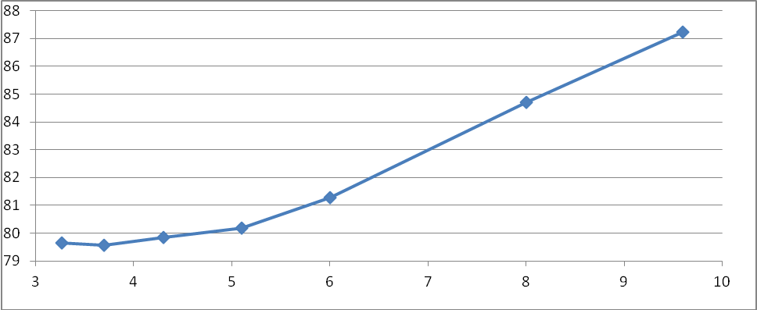
CENTER FREQUENCY - MHz
EFFICIENCY - %
VS. OPERATING FREQUENCY

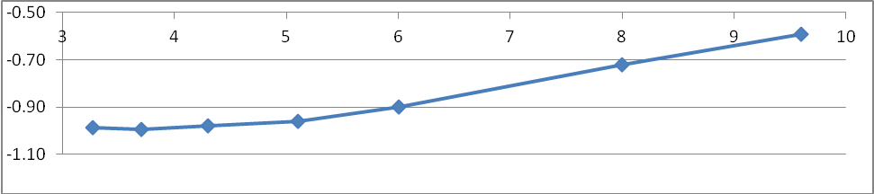
CENTER FREQUENCY - MHz
EFFICIENCY - dB

For additional information please go to:

www.alphacognetics.com

